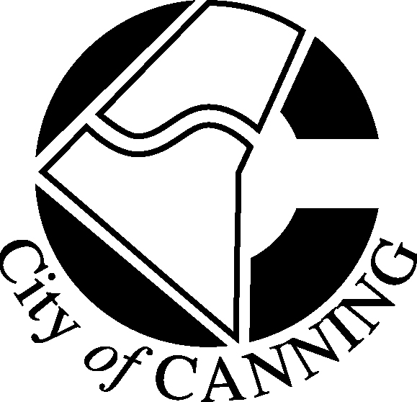

COMMUNITY FEEDBACK FORM

PROJECT: THE DEVELOPMENT OF DABCHICK PARK, EAST CANNINGTON

Please return by Tuesday 29 September 2015

To: | NANETTE NGUYEN  Parks & Environment  By post: City of Canning  Locked Bag 80  WELSHPOOL  W.A. 6986  By email:  customer@canning.wa.gov.au  Subject line please put: Nanette Nguyen and the project title. | From:  Address:  Phone  Email | ____________________________  ____________________________  ____________________________  ____________________________  ____________________________
1 | How many people are in your household? __________________________________
2 | What is the adult age range? (eg. between 30-40)_______________________________
3 | If there are children, how many and how old are they?_________________________
4 | Overall, do you support the concept plan for Dabchick Park? (Please tick the box)
Yes No

5 | Is there any aspect of the design that you particularly like?  __________________________________________________________________  __________________________________________________________________
__________________________________________________________________

6 | Is there any aspect of the design that concerns you?  __________________________________________________________________  __________________________________________________________________
__________________________________________________________________

7 | Comments:  __________________________________________________________________  __________________________________________________________________

DATE:___________________________ SIGNATURE___________________________________

